Name
Please circle what you would like to buy
T-shirt - £15 each in black
Small Medium Large Extra Large
Hoodie - £20 each
Style
Zip No zip
Size
Small Medium Large Extra large
Name/wording on back (no maximum characters)

Colour.
Black red green blue pink purple

Other colours and kids sizes available. Please ask for further details
Amount paid.......................................................
Contact number/email so we can inform you when the order has arrived. Order will be available to collect at the next event or from St Cuthberts Hall (selected times).
............................................................................................................................................
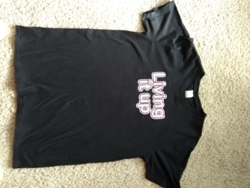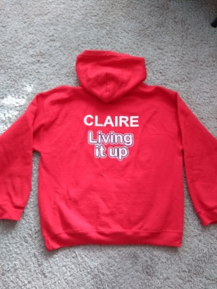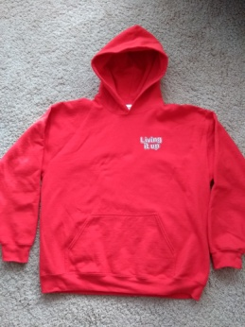
T shirt Example of hoodie, back and front

